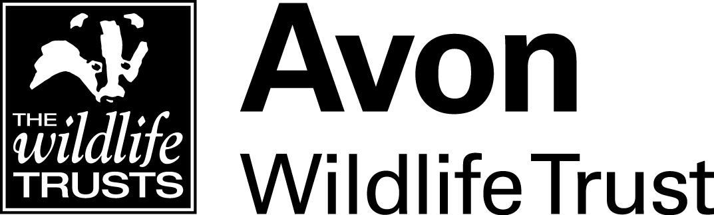

VOLUNTEER ROLE DESCRIPTION
Title: | Our Bright Future/ Learning Team Volunteer
Responsible to:  Desirable frequency  duration: | Our Bright Future Project Officer  Taster session Tuesday 1st June  Tuesday mornings for six weeks through Summer Holidays  Alternate Saturdays September onwards  Taster Day and six week pilot minimum commitment
Based at: | Grow Wilder 131 Frenchay Park Road

Key purpose of volunteer role
To support a group of young people to engage with conservation, wellbeing and learning opportunities at Grow Wilder. Assisting a young leader as they develop the skills to lead and plan some of the sessions after 6-week summer pilot.
Areas of volunteer activity
Tasks may include any or all of the following:
- Attend family taster day to engage families of fostered children who will be invited to join a new youth led project. (Project name TBC)
- Attend six weekly sessions through the Summer to support the establishment of the group alongside a member of the AWT learning team.
- Contribute to content and planning of sessions during pilot and September onwards.
- Support, alongside AWT staff, the young people to develop skills to lead the group after initial six weeks.
- Continue to support the cohort as they meet from September onwards with support from the AWT learning team.
- Attend training, eg First Aid, as required.

Desirable attributes and skills

- Enthusiasm to support and inspire young people.
- An enthusiasm for conservation and wildlife.
- An enjoyment of working outdoors in variable weather conditions.
- Have some experience facilitating activities.
- Excellent communication and time management skills
- Able to work as part of a team and follow instructions.
- An interest in Avon Wildlife Trust and its values

Values of the Trust

Acknowledging the exceptional importance of wildlife and the natural environment to the health and sustainability of the planet’s climate and eco-systems
- Promoting the crucial social and economic benefits provided by wildlife and the natural environment to the health and well-being of the human population
- Maximising social inclusion by promoting opportunities for of all members of the community to take part in the Trust’s work and activities
- Delivering the Trust’s objectives by working as far as possible through partnerships with other organisations and community groups

Promoting opportunities for volunteering, and developing the skills, interests and personal development of its volunteers
- Taking pride in the Trust’s role as a community enterprise created by and responsible to its members
- Fostering a culture of innovation, inspiration and creativeness in its own internal working to create a visionary and dynamic Trust
- Demonstrating openness and transparency to all its external audiences, partners and customers operating at all times with total probity, supporting ethical trading, and minimising its own carbon footprint

This role description reflects the hopes an intentions of the volunteer and the Trust, and is not contractually binding in any way on either party.
Out of pocket travel expenses, upon submission of valid receipts, will be reimbursed.
Support and training will be provided throughout the placement
All volunteers are required to abide by the Trust's Policies, Procedures and other Key Documents as posted on the Trust Intranet and provided as part of the Volunteer Induction Pack.
Due to the work with vulnerable groups and young children we will require you to be DBS checked (Avon Wildlife Trust will pay for check for successful candidate).

Deadline: Friday 30th April 2021

Please send your C.V. and a covering letter outlining why you would be a suitable candidate for the placement to: ourbrightfuture@avonwildlifetrust.org.uk or post to Our Bright Future. Avon wildlife Trust, 32 Jacobs Wells Road, Bristol. BS8 1DR.

Shortlisted placements will be invited to an informal interview via Zoom or Teams

