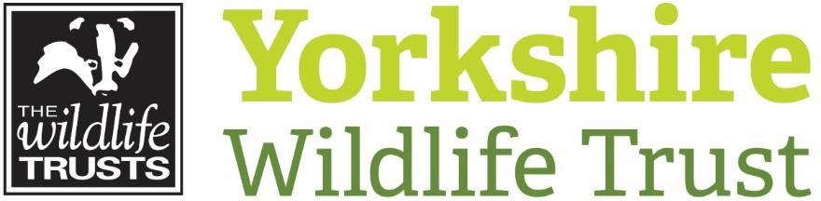
Avon
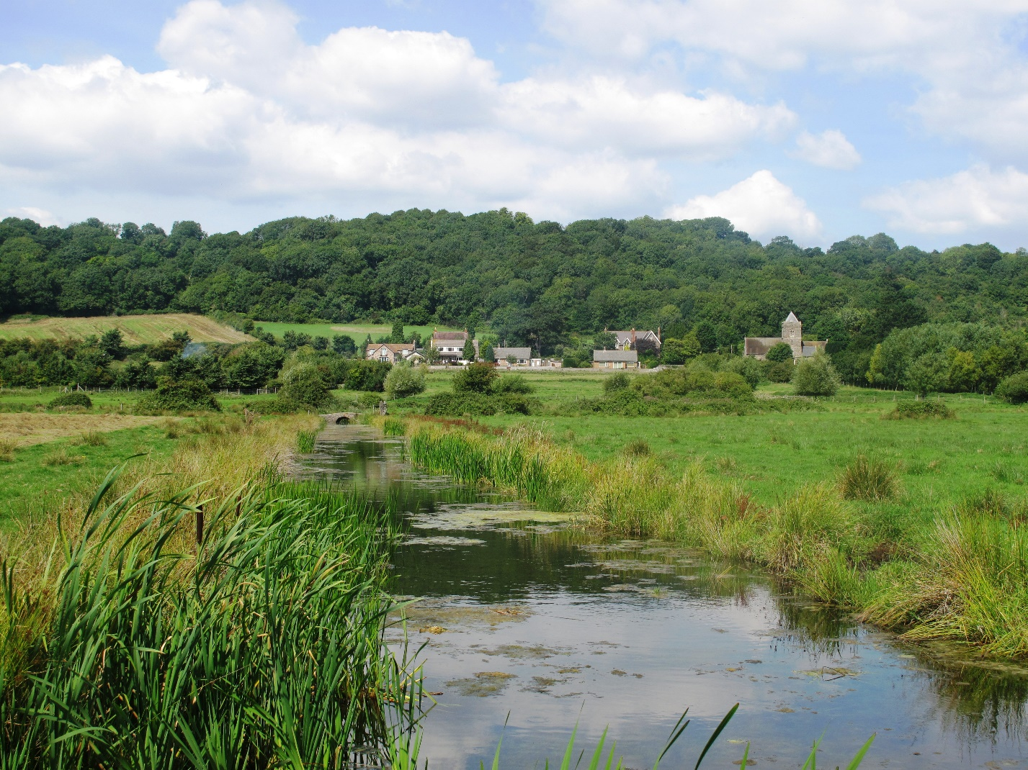

Head of Commercial

Avon Wildlife Trust
Avon Wildlife Trust is the largest local charity working to protect wildlife in the West of England area (which includes Bristol, Bath and North East Somerset, North Somerset and South Gloucestershire). It is one of the 46 Wildlife Trusts and the Royal Society of Wildlife Trusts that together collectively form The Wildlife Trusts Partnership. Together, they are the biggest organisation in the UK working solely for nature.
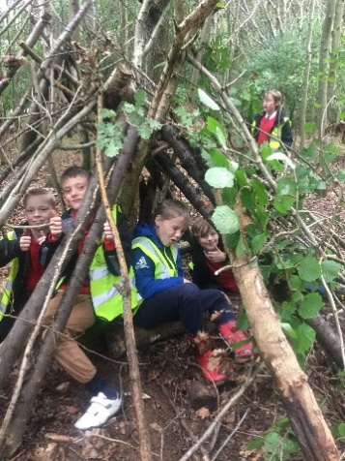
Today, Avon Wildlife Trust employs 35 staff and works alongside over 1,500 volunteers, supported by over 17,000 members. We work to bring wildlife back through the management of restoration of habitats and to inspire people to take action for wildlife. We manage 30 nature reserves, covering over 1,000 hectares of land from ancient bluebell woods to Iron Age forts, nationally important wetlands, and wildflower meadows. The Trust involves people in nature’s recovery by supporting, equipping and empowering them to take action in their communities and through events, award-winning educational and community programmes, and through the quality of experience of visiting our nature reserves. The Trust communicates and advocates for nature across the West of England, working with MPs and local Councils to ensure the importance of nature is reflected in legislation and local plans. And we work with landowners in the wider countryside, to create living landscapes where people and wildlife can thrive.
Our Plans
Avon Wildlife Trust’s vision is to see nature recovering on a grand scale across Avon and everyone in our community able to enjoy wildlife on their doorstep. We are at the start of an exciting new ten-year strategy to achieve this.
We will enable the recovery of wildlife by managing our land and working in partnership to restore, create and connect habitats to increase species abundance. We will inspire and support people to connect with nature and take action for wildlife where they are.
We want to see nature playing a full role in tackling the climate crisis and local environmental issues through new and restored habitats that absorb and store carbon, reduce flooding and pollution, and more than offset the impacts of development - and we are actively developing new products, platforms and funding streams to facilitate public and private investment in these environmental services.
Our strategy will be underpinned by a range of enabling priorities, including:
- Increasing our capacity to take and support action by growing and diversifying our income streams to provide stable, sustainable funding and generate a small surplus each year
- Developing more hubs where we can engage, inspire and equip people to take action for nature and provide suitable bases of operations for staff and volunteers across Avon

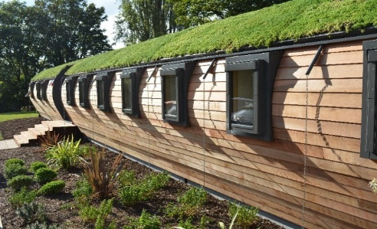
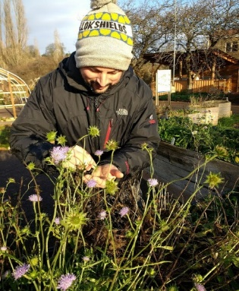

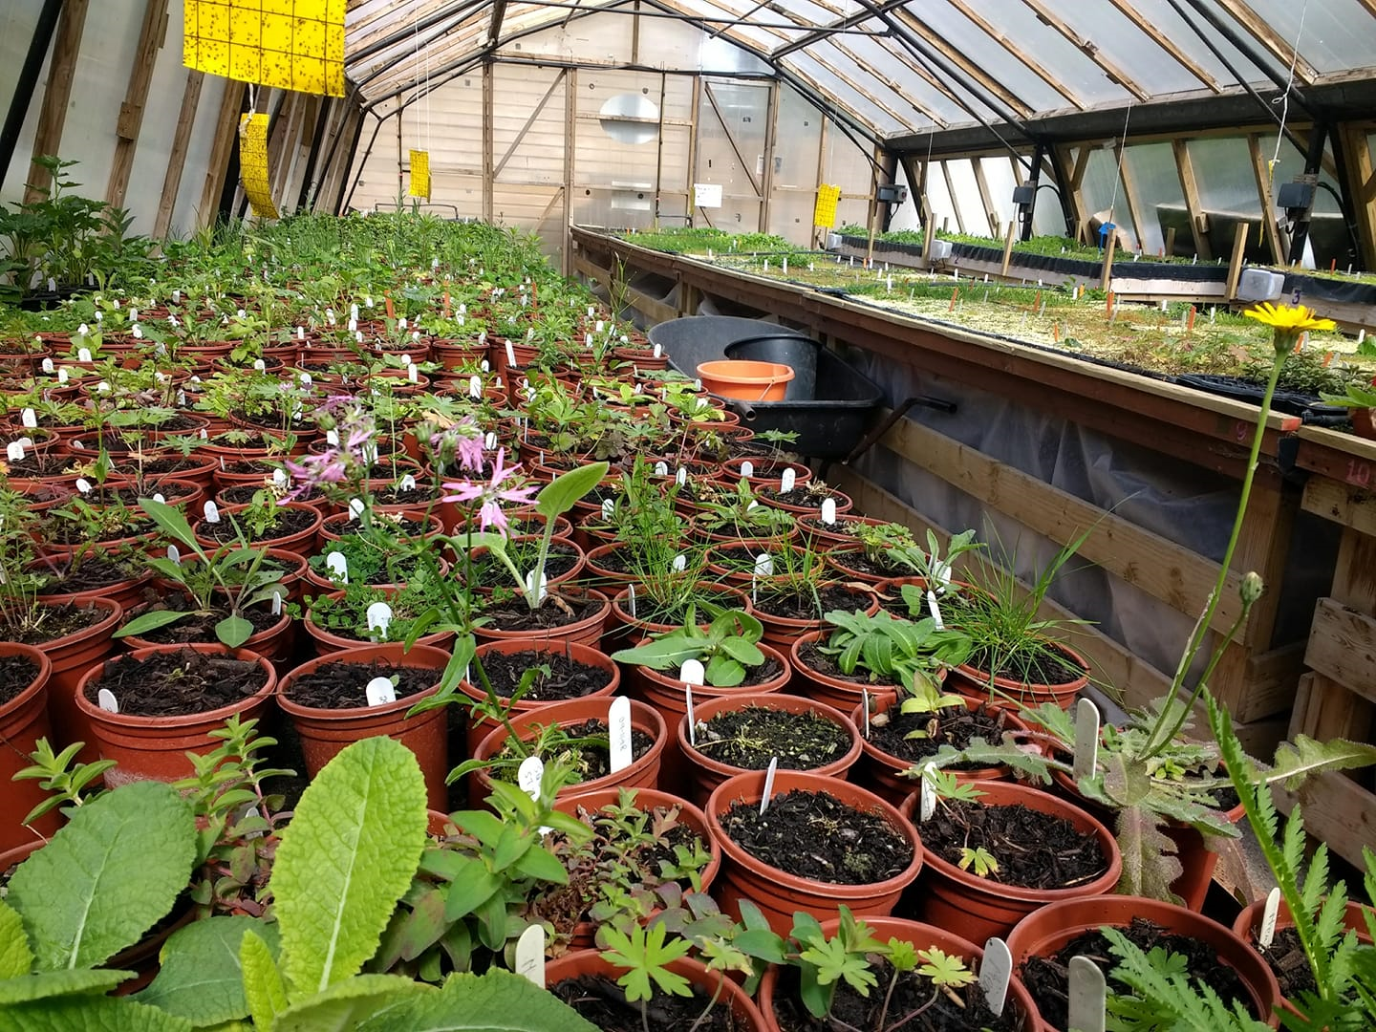
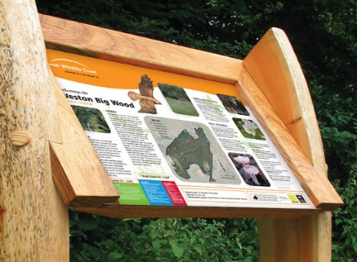

Commercial
This is an exciting time to be joining the Trust as we are developing ambitious plans to invest in our future. We are looking at how we can develop our commercial offer, products and services to support nature’s recovery through what we do and the revenue generated to support our wider work.
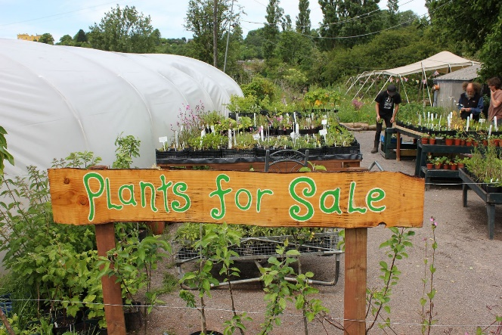
Business Development – the Trust undertakes a number of commercial activities within our charitable activities, including wildlife education courses, venue hire and a wildflower nursery at Grow Wilder in Stapleton. We have ambitious plans to develop new engagement hubs and visitor centres which will provide additional commercial activity and income streams through retail and catering. We own over 1,000 hectares of land, including woods and farmland, which also provide opportunities for nature-friendly revenue generation such as the production and sale of charcoal, or potentially wildlife holidays along the Knepp Safari model. We want to ensure that our commercial activities are set up in the best way possible to develop and provide income for the Trust’s work. We want to explore and develop the opportunities for new income streams, and models for managing our land in ways that help to fund and directly deliver our nature recovery objectives. This role will lead on identifying, driving and developing commercial opportunities across the Trust.
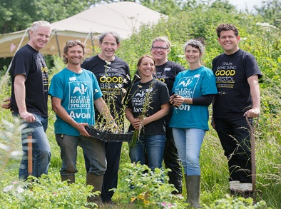
Engagement Hubs – places where we can engage, inspire and equip people to take action for nature are central to our new strategy. Grow Wilder currently engages over 12,000 people every year, aiming to bring about urgent action for the restoration of wildlife by educating, upskilling and empowering people, communities and businesses to bring about positive change through wildlife-friendly gardening and sustainable food growing. Plans for new and improved visitor, café, retail and community facilities at Grow Wilder are well advanced.
We are developing a pipeline of proposals for engagement hubs and visitor welcome facilities across our area and in our nature reserves, such as our recent proposals for an Art And Nature Discovery Centre in Bath, which we are working with the Council to find an alternative location for. Engagement hubs and visitor centres provide a safe location from which people can explore new landscapes and habitats – with clear access, toilets and somewhere to get a cup of tea and some cake. Improved paths, ponds and bird hides provide more places where people can see and experience wildlife. The Head of Commercial role includes management oversight of the Trust’s engagement hubs and driving development of new sites and locations, ensuring a high quality, profitable hospitality, catering and retail offer that supports visitors’ experience of nature at our reserves.
Nature-based Solutions – the Trust is actively involved in developing new products and platforms for securing public and private investment in improvements to natural habitats that will help nature’s recovery - such as Wilder Carbon. Securing investment in nature-based solutions will be critical to supporting nature’s recovery. Environmental credits generated from habitat improvements - such as carbon credits, biodiversity net gains credits and measurable reductions in flood risk and pollution - can be marketed to businesses, developers, water companies and local authorities, with the income used to fund habitat improvements and profits reinvested in future projects. This role will lead on developing commercial elements of nature-based solutions platforms.
Building with Nature - our area will be the focus for a lot of housing and infrastructure development over the next few years, with an additional 105,000 homes planned by 2036. This is one of the key risks for wildlife in the area, but also provides opportunities to create and restore habitats and wildlife corridors through “planning gain”. Building with Nature (BwN) provides an opportunity for working with developers to ensure that development helps rather than harms wildlife and this role will lead on developing BwN as a commercial offer.
Application
Many thanks for your interest in this post. We hope that the job pack provides enough information for your application. If you would like more information or just find out a bit more about this post and AWT, you can contact our Chief Executive, Ian Barrett, for an informal conversation, by calling 0117 9177270.
Application is through a three-step process that will hopefully whittle the application list down to the perfect candidate for the job. It starts with AWT’s standard application form, so please fill this out, paying particular attention to the details of your relevant experience, knowledge and skills, which is used for shortlisting against the person specification. It is best not to assume prior knowledge and higher scoring is more likely if you explain carefully why you meet the person specification rather than simply stating that you meet it.
The deadline for receipt of completed application forms is Monday 26 April.
Completed application forms should be emailed to hr@avonwildlifetrust.org.uk.
Please note that it is not always possible for us to acknowledge receipt of applications due to limited staffing resources.
Step 1 – Apply by filling in the application form. CVs may be supplied as additional information but will not be used for initial shortlisting, rather used in subsequent steps. Deadline: 26 April. This process will produce a shortlist of candidates.
Step 2 – Shortlisted candidates will be invited for interview by an initial selection panel. First interviews will be on or around Tuesday 4 May
Step 3 – Second interview for leading candidates will be on or around Thursday 13 May
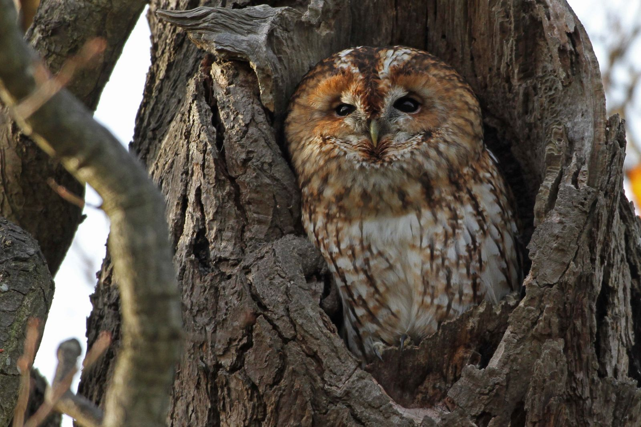
(Please let us know in your application if you are unable to make any of these dates - we may be able to arrange a suitable alternative)

1. JOB DESCRIPTION

Job Title | : | Head of Commercial
Team | : | Senior Leadership
Working Base | : | AWT Head Office
Responsible to | : | Chief Executive
Responsible for | : | Engagement hub managers and staff, including Grow Wilder Business Manager and Grow Wilder Site Manager
Overall Purpose of Job | : | To lead the development of Avon Wildlife Trust’s commercial activities, developing new markets and opportunities and increasing net revenues to support the Trust’s wildlife conservation and engagement work.
Main Responsibilities | : | - Lead the development of commercial income streams across the Trust, working with colleagues to grow net income by developing products and improving the provision of services  - Lead the development and management of visitor centres and engagement hubs for the Trust, delivering an excellent retail and catering experience to all our visitors that contributes positively to their experience of nature at Avon Wildlife Trust sites  - Develop and oversee all commercial aspects of the Trust’s offer on habitat-based carbon credits, biodiversity net gain and similar environmental goods and services, exploring opportunities to secure significant new private, corporate and public sector investment  - Manage Departmental staff, maintaining a safe, professional working environment with a positive high-performance culture. Contribute to the development of commercial skills, competencies and approaches across the organisation, including systems for managing staff utilisation  - Contribute to the Trust’s ongoing management, strategy and future direction as an active member of the Senior Leadership Team, preparing and presenting reports on commercial activities and ensuring they are aligned with and support achievement of the Trust’s wider objectives

2. JOB SPECIFICATION

Management and Supervision | : | Supervision of all staff in the Commercial Department, including line management of team leaders.  Programme and project management of business improvement projects, including input from staff throughout the organisation.
Accountability and Resources | : | Responsible for the planning, monitoring and control of Departmental budgets, equipment and resources, including the development and maintenance of visitor centres and hubs
Job Impact | : | Ensures a strong commercial approach is applied to work throughout the Trust, putting in place systems and processes and managing staff to ensure high standards and an excellent level of customer service to people purchasing goods and services, or visiting the Trust’s centres.
Independence and Judgement | : | Shapes development of the Trust’s commercial activities in collaboration with colleagues, analysing options and making recommendations for new or improved products and services.  Sets and maintains work standards for retail and catering operations.
People and Contacts | : | Works with partners, suppliers and funders at all levels to explore and develop new products and services across a wide range of work areas.
Creativity and Innovation | : | Develops the Trust’s products and services to meet the needs of customers. The post-holder will need to have the ability to undertake work of a complex and diverse nature.
Working Conditions | : | Based at AWT Head Office, with home working. Frequent travel to sites required. Some evening and weekend working for site and project management, events and networking.

3. PERSON SPECIFICATION

Experience | : | - Strong track record in commercial management, including successful development and management of products and services (E)  - Proven track record of managing budgets, finances, projects and contracts. Record of setting and delivering performance targets (E)  - Significant experience in management of staff (E)  - Experience of effectively managing operational risk, including Health and Safety (E), compliance, fire, security and emergency procedures, and food hygiene (D).  - Experience of management and developing operations in catering, retail, hospitality or similar sectors (D)  - Experience of leading a culture of exceptional customer service (D)  - Experience of working in the not for profit sector and with volunteers (D)
Competence, Knowledge & Skills | : | - Degree in business or management, or equivalent experience (E)  - Proven leadership skills, the ability to coach, train and lead people to do their jobs well (E)  - Excellent financial analytical skills (E)  - Ability to prioritise, demonstrating first class organisational and time management skills (E)  - Good knowledge of programme and project management, with the ability to lead the development of projects (E)  - Expertise in writing business plans and options appraisals (E)  - Efficient and organised. A good understanding of process and excellent attention to detail, with the ability to work accurately in a busy and demanding environment (E)  - Ability to work at pace, get things done and meet deadlines (E)  - Excellent people and influencing skills, enabling relationships externally and internally to be built and maintained (E).  - Strong written, verbal and presentation skills (E)  - Expert negotiating and influencing skills (D)  - Proven ability to develop and respond to audience insight to improve and develop an offer (D)  - Able to foster an organisational culture that is positive about change and committed to delivery of the strategic plan (E)
Personal Qualities | : | - A strong and inspiring leader with excellent interpersonal and organisational skills, able to harness the commitment and enthusiasm of staff.  - Tenacious and results driven.  - Commercially astute and customer focused.  - Passionate about achieving high levels of excellence.  - An eye for innovation. Able to work ideas into workable commercial proposals  - Sound judgement with a calm, confident, mature and pragmatic approach.  - Highly energised and motivated with a high level of commitment  - Flexible, positive ”can do” attitude  - Ability to work proactively using own initiative.  - Encourages an organisational learning approach (learns from success and failures and seeks staff and other stakeholder feedback).  - Tact, diplomacy and integrity  - An appetite for continued professional development  - Personal values that align with those of the Trust and a commitment to the Trust’s goal of inspiring and equipping people to take action for wildlife  - Willingness to work flexible hours as required  - A valid driving licence

Salary: | £37,000-£42,000 per annum depending on skills and experience
Contract: | Permanent
Hours: | 37 working hours per week, Monday to Friday. A flexible approach to work will be required with some early morning, evening and weekend working potentially needed to effectively manage projects. Paid overtime is not available, but time off in lieu will be given.
Holidays: | 25 days of paid leave each year (or part-time equivalent), including up to four days to be taken when the office is closed for Christmas/New Year
Flexibility: | Subject to ensuring that the needs of the business and the role are met, the Trust, where possible, endeavours to meet the flexible working needs of its employees.
Pensions: | You will be eligible to be auto enrolled into The Trust’s Group Personal Pension Plan arrangement. The Trust will contribute 5% of salary into the Plan. Staff can contribute to the scheme and under Auto-Enrolment legislation a minimum employee contribution of 3% is required.
Equal  Opportunities: | Nature is for everyone and Avon Wildlife Trust is committed to building an inclusive organisation where the workforce reflects the cities and areas we serve and where colleagues feel confident about being themselves at work. Applications are welcome from people of all backgrounds, regardless of regardless of gender, sexual orientation, race, disability, marital status, age and religion, and are particularly encouraged from sections of society that are under-represented in the conservation sector. All appointments are made on merit.
Notice Period: | 12 weeks following satisfactory completion of a six month probationary period.
Place of Work: | The post will be based at the Trust’s headquarters in Bristol.
Training: | The Trust is fully committed to personal development and training.

Avon

