How to share your postcard from the future
You can upload your postcard directly to Padlet by using the quick steps below. Once they are uploaded a group of experts and young people working in the environmental sector will go through and give you feedback on your vision for nature in the future.
- Click on the Postcards from the future link here: https://padlet.com/NaturalHistoryConsortium/15863xkwk706jl92

- Double click anywhere on the Padlet to create a post
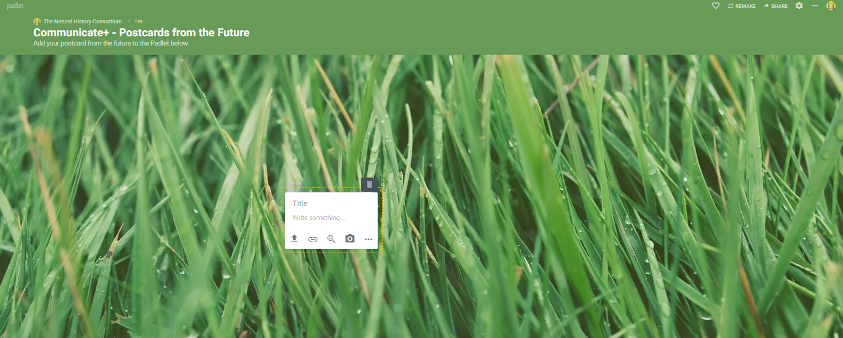

- Click the “Upload” symbol

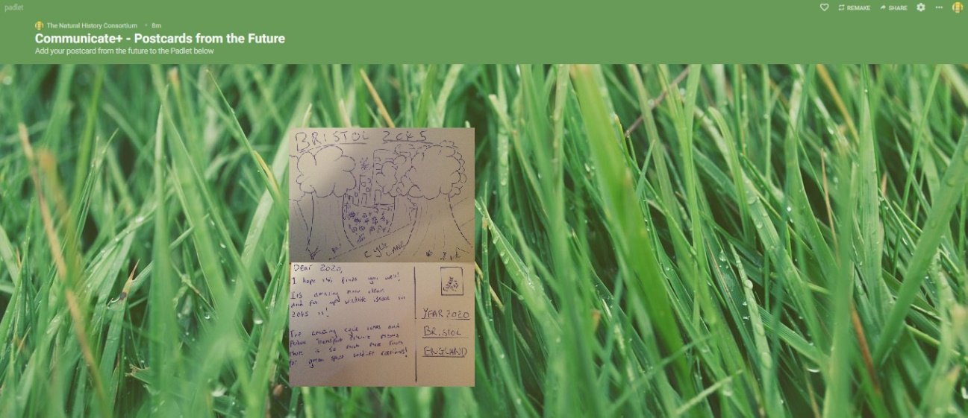
- Find your Postcard on your device and upload it to the Padlet

- You’re done! Look at other people’s postcards and see what their vision for the future looks like.

