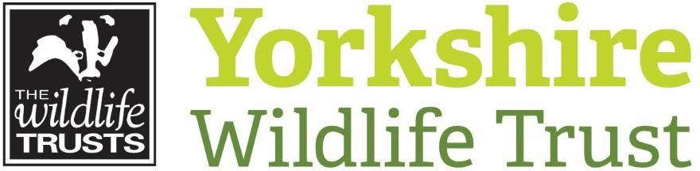
Avon
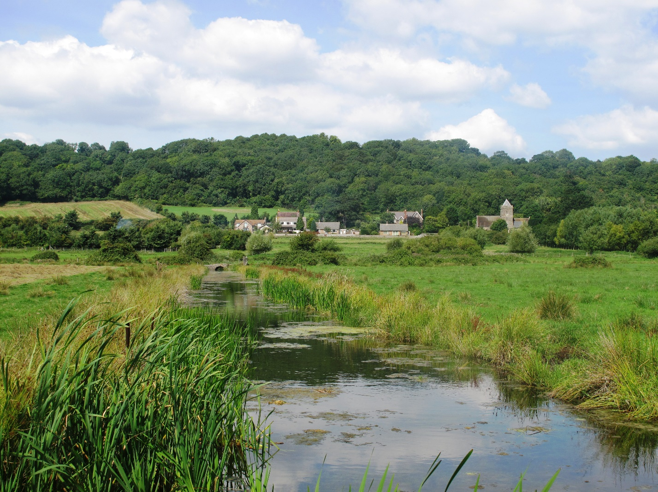

Head of Fundraising

Avon Wildlife Trust
Avon Wildlife Trust is the largest local charity working to protect wildlife in the West of England area (which includes Bristol, Bath and North East Somerset, North Somerset and South Gloucestershire). It is one of the 46 Wildlife Trusts and the Royal Society of Wildlife Trusts that together collectively form The Wildlife Trusts Partnership. Together, they are biggest organisation in the UK working solely for nature.
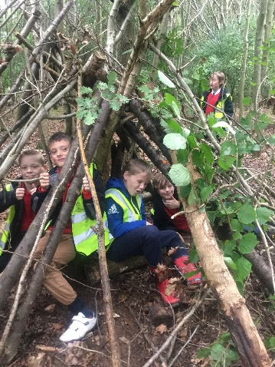
Today, Avon Wildlife Trust employs 40 staff and works alongside over 1,500 volunteers, supported by over 18,000 members. We work to protect wildlife and inspire people. We manage 30 nature reserves, covering over 1,000 hectares of land from ancient bluebell woods to Iron Age forts, nationally important wetlands, and wildflower meadows. The Trust involves people in nature conservation through the simple inspiration of visiting a Trust nature reserve, through events, through volunteering, and through our award-winning educational and community programmes, where we are pioneering work on urban conservation and nature and wellbeing. The Trust communicates and advocates for nature across the West of England, working with MPs and local Councils to ensure the importance of nature is reflected in national legislation and local plans. And we work with landowners in the wider countryside, to create living landscapes where people and wildlife can thrive.
Our Plans
Avon Wildlife Trust’s vision is to see nature restored on a grand scale across the West of England. Our 5 year strategy sets out our goals to:
- Create ecological networks through landscape-scale habitat management and enhancement
- Inspire people and communities to care for nature
- Champion the value of nature
This is an exciting time to be joining the Trust as we are developing ambitious plans to invest in our future: upgrading and expanding our facilities for education, community engagement and visitors; developing new headquarters for the Trust; and looking at how we can develop our nature reserves and the facilities within them to bring even more benefits for wildlife, provide new places and experiences for people to be inspired by wildlife, and provide sustainable revenue for our work to create wildlife-rich places and wildlife-rich lives. We want to create:

Living Landscapes where…
- wildlife is abundant and thriving in our towns and cities, and across our rural landscape – from mountain top to seashore;
- whole landscapes and ecosystems have been restored to provide a resilient foundation for the lives of wildlife and people, for generations to come;
- wildlife can move freely across the land and along its watercourses, adapting to a changing climate;
- natural habitats and soils accumulate and store water and carbon – helping to slow down climate change and to reduce the risk of droughts and floods; and
- people are inspired by wildlife and value it for the many ways in which it supports our health, wellbeing and quality of life.
Living Seas where…
- marine wildlife is abundant and thriving, from the depths of the ocean to the coastal shallows;
- wildlife and habitats have recovered from past declines as our use of the sea’s resources has come back into balance with their ability to renew themselves year after year become environmentally sustainable;
- the natural environment is adapting well to a changing climate;
- ocean processes are helping to slow down climate change; and
- people are inspired by marine wildlife and value the sea for the many ways in which it supports our quality of life.

A Society Where Nature Matters… in which it is normal for people to:
- have a strong personal connection with wildlife and wild places where they live and work;
- benefit from a healthy natural environment and personal engagement with it – including better health, wellbeing and prosperity;
- understand and value a healthy, wildlife-rich natural environment, and reflect this in their attitudes and behaviours;
- take action for wildlife and wild places, to bring about nature’s recovery on land and at sea – starting close to home.

Our Fundraising
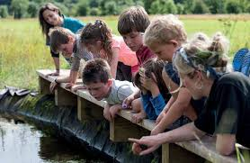
Growing our membership base, increasing our income and communicating our impact are all vital in enabling us to maintain our impact and achieve our plans for developing the Trust. We have been expanding and developing our Fundraising, Membership and Communications team over the last four years, bringing in specialist expertise and investing in new CRM and finance systems to enable us to better service our membership and track and develop our income.
Membership - we believe that we have significant potential for membership growth in the West of England. We currently have around 18,000 members, contributing over £600,000 per year. Research undertaken for the South West Wildlife Trusts suggests that around 35% of the UK population are wildlife enthusiasts who support causes such as ours, and that we have the potential to double our membership in Avon based on comparisons of penetration rates for target demographics. We want to emulate the success of Trust’s like Yorkshire who have quadrupled their membership over the last ten years.
Grants - the Trust has had considerable success in recent years in securing Lottery funding for our work on Local Wildlife Sites, nature and wellbeing and working with young people in deprived urban communities. Smaller grants have helped to fund our work on nature reserves, wildlife corridors and community engagement and our overall grant income is now over £850,000 a year. We want to build on this success to bring in more funding for our reserves and living landscapes, secure future programme funding and enable us to fulfil our ambitious plans for the Trust.
Corporates and Major Donors - individual giving is a growing area for the Trust. We have some very generous support from major donors, a good network of contacts and lots of potential supporters in Bristol, Bath and surrounding areas. Donations currently bring in around £40-80K per year for the Trust. Legacies are a growing source of income for the Trust (on average around £80K per year), which needs further development. Corporate income is also growing. We work closely with a wide range of businesses in Bristol and Bath, with a busy programme of employee engagement days and some strong partnerships, which provide a good basis for developing relationships. Finally, capital fundraising is likely to be an increased area of focus for the Trust as we develop plans for our headquarters and other facilities.
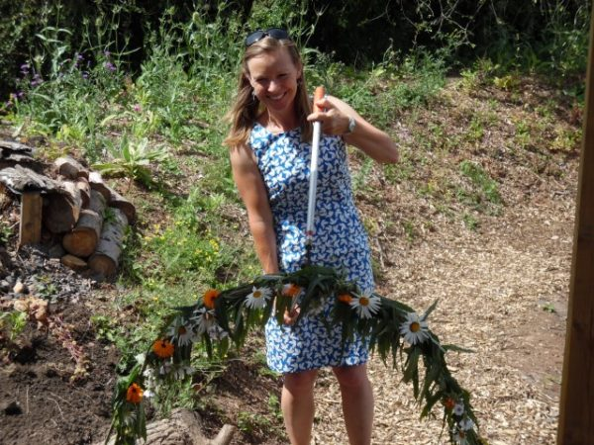
Communications and Marketing - the Wildlife Trusts brand is strong and trusted for people who know us, but more work is needed to raise wider awareness of who we are, what we do and the range and impact of our work for people and wildlife. We have developed and refined our communications messages over recent years and are playing an active role in standing up for nature locally and nationally, in the face of major planned housing development and changes to government policy.
Marketing also supports the success of our events and services, including our education and wedding venue at Folly Farm in the Chew Valley, our wildflower nursery at Feed Bristol and a full programme of Trust activities.
Systems and Processes - we have invested in new CRM and finance systems over the last three years and work is now needed to roll them out across the organisation and ensure that we are getting the best use out of them in areas including membership stewardship and fundraising. Our fundraising, membership and marketing functions have developed quickly over the last two years and more work is needed to develop the systems and processes to properly plan, track and report on our activities.

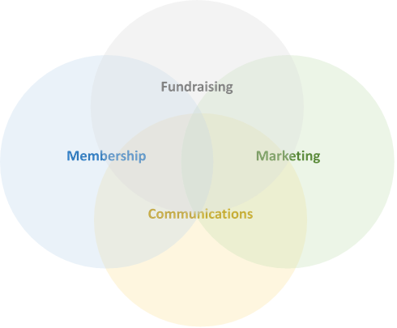
The Role
As Head of Fundraising you will shape and guide income generation for the Trust, taking a hands-on approach to fundraising of all kinds.
You will manage an integrated functional team, making the most of people’s skills to get work done.
This includes light touch line management, supervision and support for our communications team. The communications team plays a key role in working with the CEO and Delivery teams to directly achieve organisational goals through awareness-raising and influencing, as well as supporting fundraising activity.

Working Patterns
This role is available as a job share or full-time post. If you are interested in a job share, we are ideally looking for candidates with particular strength in corporate, major donor and grant fundraising.

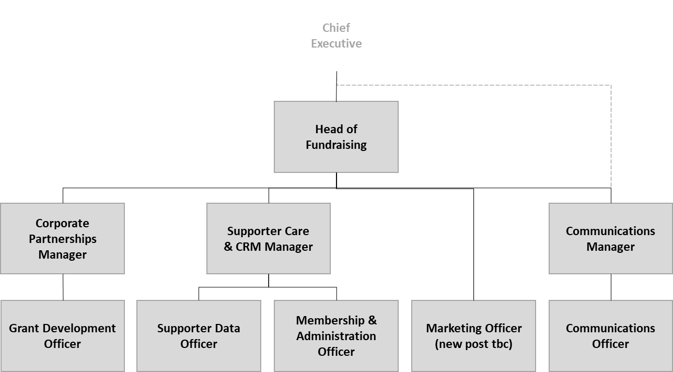
Team Structure
Application
Many thanks for your interest in this post. We hope that the job pack provides enough information for your application but if you would like more information or just find out a bit more about this post and AWT, do give Ian Barrett, our Chief Executive, a ring/e-mail for an informal chat. If Ian is not available, you could also talk to one of the Senior Management Team of Directors (phone 0117 9177270).
Application is through a three-step process designed to identify the right candidate for the job. It starts with AWT’s standard application form, so please fill this out, paying particular attention to the details of your relevant experience, knowledge and skills which is used for shortlisting against the person specification. It is best not to assume prior knowledge and higher scoring is more likely if you explain carefully why you meet the person specification rather than simply stating you meet it.
Please let us know your preference for full-time, part-time or job share and how many hours you would ieally be looking to work.
The deadline for receipt of completed application forms is 6 March 2020.
Completed application forms should be emailed to hr@avonwildlifetrust.org.uk.
Our preference (in line with our aspiration for a paper-free office), is to receive applications electronically in Word format. Alternatively, applications may be sent in paper format to:
Avon Wildlife Trust, 32 Jacobs Wells Road, Bristol BS8 1DR.
Please note that it is not always possible for us to acknowledge receipt of applications due to limited staffing resources.
Step 1 – Apply by filling in the application form. CVs may be supplied as additional information but will not be used for initial shortlisting, rather used in subsequent steps. Deadline: 6 March. This process will produce a shortlist of candidates.
Step 2 – Shortlisted candidates will be invited for interview by an initial selection panel Date: 12 March
Step 3 – Second interview for leading candidates Date: 20 March
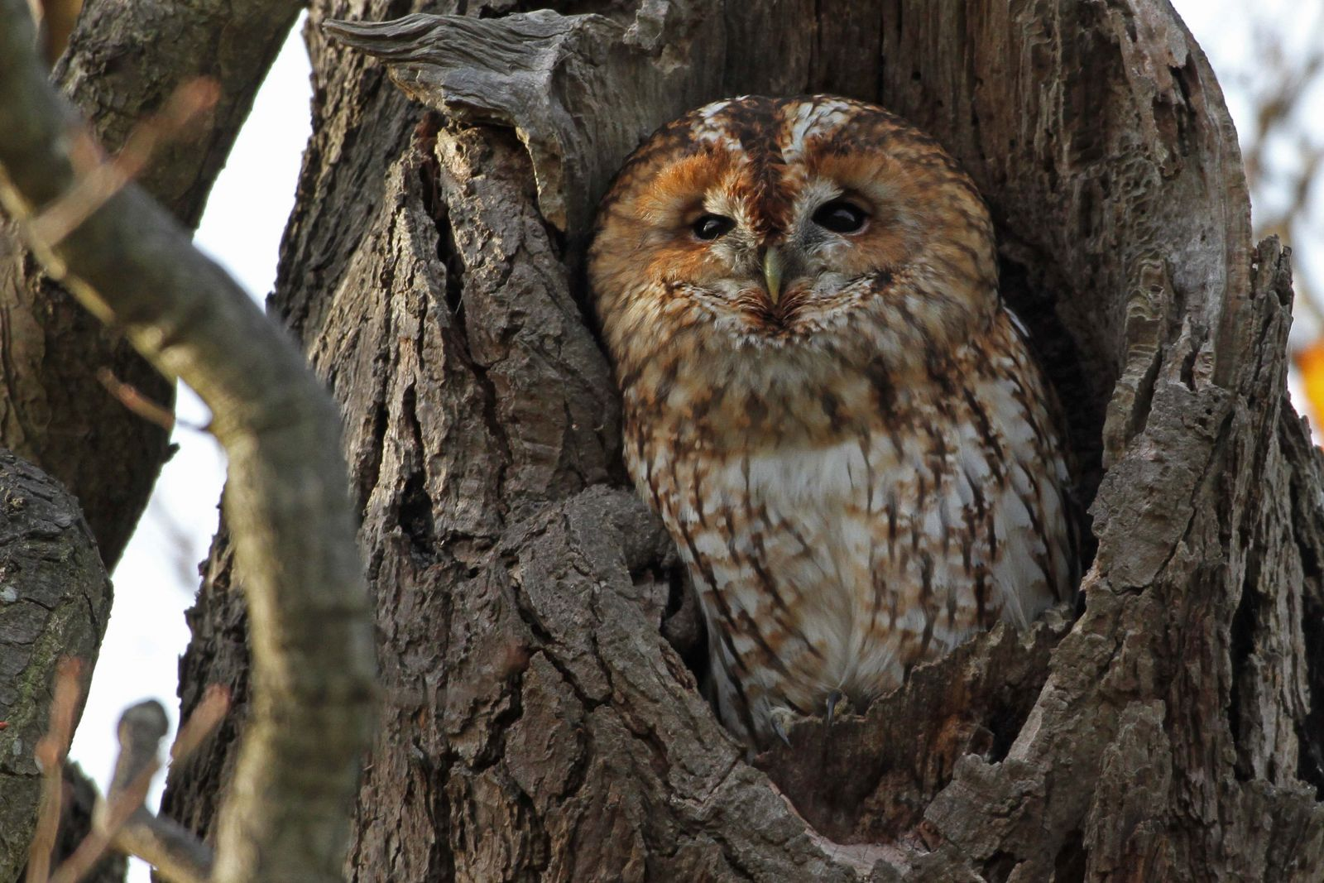
(Please let us know in your application if you are unable to make any of these dates - we may be able to arrange a suitable alternative)
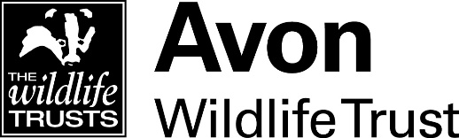
1. JOB DESCRIPTION
Job Title | : | Head of Fundraising
Team | : | Fundraising, Membership & Communications
Working Base | : | Jacobs Wells Road
Responsible to | : | Chief Executive
Responsible for | : | Corporate Partnerships Manager, Supporter Care and CRM Manager, Communications Manager
Overall Purpose of Job | : | To grow the Trust’s income to enable us to achieve our vision of restoring the abundance of wildlife throughout our area.
Main Responsibilities | : | - Lead and develop the Trust’s fundraising and income generation, developing prospect pipelines and growing income year on year from membership, major donors, legacies, corporate partnerships, grants and charitable trusts  - Manage our engagement with our members, developing and implementing an ambitious membership growth strategy, incorporating supporter development, recruitment and retention  - Manage marketing of the Trust’s fundraising, events, activities and services, working with our Communications Manager to effectively promote the Trust and ensure consistency of brand  - Ensure all activity is compliant with Data Protection and Health and Safety legislation, with fundraising guidelines promoted by the Charity Commission, Institute of Fundraising and Fundraising Regulator, and with the Trust’s policies.  - Manage an integrated functional team across fundraising, membership and communications, contribute to the direction and development of the Trust and undertake other duties in line with the role as requested by the Chief Executive

 | 2. JOB SPECIFICATION
Management and Supervision |  | : | Direct management of a number of staff and volunteers reporting to the post, as well as contractors and suppliers. You will plan and set team goals and work priorities, build a high performing team that supports the operations of the wider organisation and provides expert advice and guidance on fundraising, marketing and membership. You will help to develop a Trust-wide culture of income generation and supporter development, with a strong focus on our membership, funders and profile.
Accountability and Resources |  | : | Overall responsibility for the Trust’s income and accountability for agreeing and achieving budgeted income targets. You will develop and implement a coherent strategy for fundraising, membership and marketing that integrates seamlessly with the Trust’s delivery, communications and support functions to support achievement of our vision and objectives. You will also represent the Trust on the Board of our jointly owned face-to-face membership recruitment organisation, South West Wildlife Fundraising Limited.
Job Impact |  | : | This is a key role for the Trust, responsible for growing our resources with long-term and sustainable funding for our work. You will shape our fundraising, membership and marketing work internally and externally. Job impacts will include raising the profile of the Trust, ensuring our members are valued and engaged, and contributing to development of the Trust’s strategic direction. You will provide guidance and expertise on fundraising, membership and marketing and work with our finance and Resources team to develop systems, processes and reporting in areas including income generation pipelines and customer relationship management (CRM).
Independence and Judgement |  | : | Considerable responsibility for a variety of complex and interconnected work activities in differing situations. A high level of analytical skills, judgement and independent initiative is required. You will keep abreast of developments in best practice in fundraising, membership and marketing and integrate this into the Trust’s work.
People and Contacts |  | : | Frequent high-level contact with people in a range of different contexts. You will take a hands-on approach to fundraising; including building and maintaining strong relationships with major donors. You will maintain good relationships with funders and acknowledge their contribution and oversee our relationships with our celebrity vice presidents.
Creativity and Innovation |  | : | Considerable scope for creativity and innovation. You will lead the development of fundraising messages and appeals for the Trust in collaboration with the Chief Executive and Conservation Director, contribute to the development of future programmes and projects, and develop the case for support for our work for a range of funders. Continuous improvement of systems and processes will help to ensure that our work is as efficient and effective as possible.
Working Conditions |  | : | Based at AWT Head Office with travel to different sites as required. A flexible approach to work will be required with some early morning, evening and weekend working needed for events, networking, media work and meetings with funders.

3. PERSON SPECIFICATION

Experience | : | - Experience of charity fundraising, or closely related field, with a good track record of success (E)  - Demonstrable success in achieving financial targets in a competitive environment (E)  - Significant management experience, with good evidence of building high performing teams (E)  - Experience of preparing and managing large budgets (E)  - Experience of developing fundraising programmes and achieving targets from high value individuals, corporate supporters, trusts and legacies (D)  - Experience of writing successful funding bids (D)  - Experience of utilising a range of marketing channels (D)  - Experience of developing business plans and processes (D)  - Certified member of the Institute of Fundraising (D)  - Relevant Marketing qualifications (D)
Competence, Knowledge & Skills | : | - Excellent networking and relationship-building skills, which can be used to create fundraising relationships from multiple sources and major donors (E)  - Excellent people management and work planning skills (E)  - Understanding of modern communications media, with well-developed marketing skills (E)  - Professional and confident communicator face to face and by telephone with people at all levels (E)  - Able to present persuasively to a public audience (E)  - Excellent verbal and written communication skills (E)  - Able to prioritise a busy workload and meet deadlines (E)  - Ability to keep abreast of and comply with legislation and guidance in a highly regulated field (E)  - Good IT skills, which can be used to introduce and develop systems and processes for managing prospect pipelines and customer relationships (E)  - Effective programme and project management skills (D)  - Knowledge of fundraising legislation and Codes of Practice (D)  - Driving licence and access to transport (D)
Personal Qualities | : | - Highly motivated and professional, with high standards (E)  - Collaborative team player (E)  - Flexible “can do” attitude (E)  - Confidence to make significant face to face fundraising asks (E)  - Team player, able to work across teams to achieve goals (E)  - Proven ability to communicate well with a broad range of people (E)  - Strategic thinker, able to conceive realistic plans for the Trusts long-term benefit (E)  - Creative and solution focussed (E)  - Tactful and sensitive to the needs of individuals and stakeholders (E)  - Ability to work flexible hours (E)  - Passionate about the environment and wildlife conservation (E)
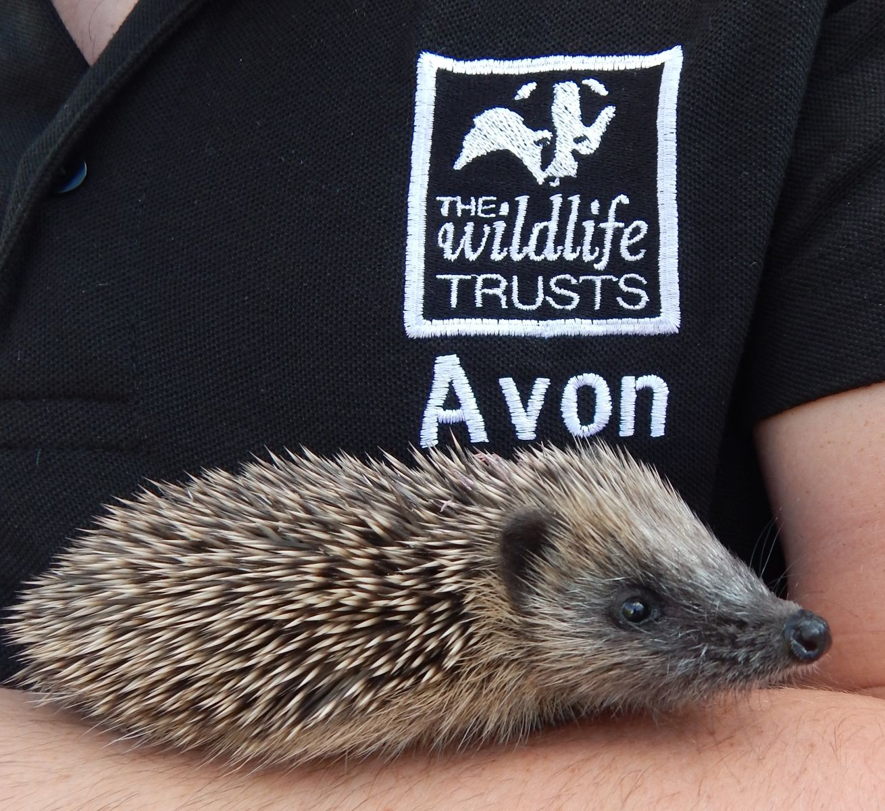

Salary: | Negotiable. From £37,000 per annum FTE, depending on skills and experience
Hours: | Negotiable. This role is open to applications on a part-time (job share) or full-time (37hrs/wk) basis. The nature of the post’s duties may from time-to-time require evening and weekend work. Paid overtime is not available, but time off in lieu will be given.
Flexibility: | Subject to ensuring that the needs of the business and the role are met, the Trust, where possible, endeavours to meet the flexible working needs of its employees.
Pensions: | You will be eligible to be auto enrolled into The Trust’s Group Personal Pension Plan arrangement. The Trust will contribute 5% of salary into the Plan. Staff can contribute to the scheme and under Auto-Enrolment legislation a minimum employee contribution of 3% is required.
Equal  Opportunities: | Avon Wildlife Trust is committed to equal opportunities and appoints on merit. We welcome applicants from all sections of society regardless of gender, sexual orientation, race, disability, marital status, age and religion, perceived community background or political beliefs.
Notice Period: | 12 weeks following satisfactory completion of a six month probationary period.
Place of Work: | The post will be based at the Trust’s headquarters in Bristol.
Travel: | Public transport is encouraged although pool vehicles are available. In exceptional circumstances the use of the officer’s own vehicle may be necessary for business use for which a set mileage rate will be paid.
Training: | The Trust is fully committed to personal development and training.

Avon

